MASS MEDIA VIOLENCE:
A RISK FACTOR FOR GANG PARTICIPATION

An Independent Research Project
Presented by
Derrick Kiser
to
Jeanne Cyr Trinque, M.A.
Faculty Advisor

In partial fulfillment of the
requirements for the degree of

Master of Education
in the field of Counseling Psychology

Cambridge College
Springfield, Massachusetts

July 25, 2012

This is an Independent Research Project Proposal in which copyright subsists.
Copyright by: Derrick Kiser
July 25, 2012
All rights reserved.
This manuscript is not intended for publication. This copy is not for distribution to the public or anyone else.
Acknowledgements
This author would like to thank the following people for their support, encouragement and assistance in the development of this independent research project. Jeanne Cyr Trinque, M.A., and Jessica Wozniak, Psy.D. Faculty Advisors, Cambridge College, Springfield, Massachusetts.

Abstract
The purpose of this study is to elevate mass media violence as a major risk factor for gang participation. Gangs can be found today in the United Sates among every culture, race and gender. Each generation of gang members seems more violent than the one it preceded. This author believes that violent media exposure contributes to the underlying causes leading to gang involvement. This author conducted a self-designed survey with 150 participants including those who self-identified as former or current gang members. Participants included males and females, ages 14 through 27, of diverse race, culture and socioeconomic backgrounds. The survey tool consisted of 43 questions covering demographic information, education, household size, race, age, and culture. The survey identified participants who self-identified as gang members or non-gang members. The survey highlighted at what age participants became involved with gangs and why they became involved. It also highlighted media usage in hours, type of media preferred and selection of media material. The results demonstrated that gang members were exposed to violent mass media at higher rates than non–gang members. They also showed that gang members preferred violent media material, and imagined themselves as the characters in the movies, videos and video games they interacted with. These participants also had greater access, with the greatest number of TV sets in the home. They also had greater control over what is watched in the home. They listened to more hours of hip-hop or Rap music with violent lyrics and accessed the internet more than non-gang members, although all participants enjoyed movies, music and the internet. The gang members selected those movies, music, and video games that incorporated violent material at twice the range of the non-gang members. The number of males was statistically higher then that of females, and Latinos and African Americans self- identified as gang members in greater numbers than all other groups.
Table of Contents

Chapter 1: ------------------------ -----------------------------------------------------------------1
Introduction

Statement of the Problem----------------------------------------------------------------1.
History of the Problem------------------------------------------------------------------- 4.
Rationale for the Study-------------------------------------------------------------------6.
Operational Definitions-------------------------------------------------------------------7.
Research Questions------------------------------------------------------------------------9.
Chapter 2: --------------------------------------------------------------------------------------------10
Review of Literature

Chapter 3:---------------------------------------------------------------------------------------------26
Methodology

Chapter 4: ---------------------------------------------------------------------------------------------29
Results

Chapter 5: ---------------------------------------------------------------------------------------------37 Summary/Discussion/Recommendations

Appendix A: Survey----------------------------------------------------------------------------------41
References ---------------------------------------------------------------------------------------------45
Resume--------------------------------------------------------------------------------------------------51

Chapter 1
Introduction
Statement of the Problem
The growth of gangs over the last three decades has increased almost twofold. Gang activities have expanded beyond the inner cities and are now in cities (80%), towns, and
rural areas (20%) throughout the United States. According to the 2009 National Youth Gang Survey, there are approximately 28,100 gangs estimated to have been active in the United States in 2009. The number of gang members is estimated at 731,000, an increase of 34.5% from 2008 to 2009. Half of all gang members in the United States are Hispanic/Latino, 32% are African American/black, and 11% are Caucasian/white. As most gang members join
in early adolescence (12 to 15), prevention should be a critical strategy within a comprehensive response to gangs. Peers within the community usually recruit gang members and they
often carry out initial acts of violence within their own or rival groups’ communities. Therefore, community members are the first to recognize the growth of gangs in a given area (Egley, Howell & Moore 2011).
Gang membership holds a tremendous amount of attraction for youth. The lure of money, drugs, popularity, sex, parties, and entertainment are strong. The changes in youth attitudes and behaviors are immediate. They grow less involved and interested in academic pursuits, non-gang affiliated friends, family interaction and old social settings. Gang membership serves as a vehicle for the development of youth identity and acceptance among peers. When there is a lack of support and the family and community no longer provide for the needs of youth, the gang becomes a surrogate family (Howell, 2010).
With increased community awareness of gang activity and crime concerns, public demand for law enforcement to address the problem of gangs is called for. With limited resources for gang abatement throughout the country, law enforcement and government officials have introduced state, judicial, and legislative action as a strategy to reduce gang violence. This new gang legislation was created in several states and set in motion gang injunctions, deterrents and mandatory sentencing laws. However, when armed assaults and youth homicides continued to escalate, it gained the attention of federal government which initiated federal gang legislation to impose social control through arrests, formal prosecution, mandated treatment or punishment (Kidder, 2007).
In the 1980s, the federal government initiated the Comprehensive Crime Control Act, and later the Gang Abatement and Prevention Act of 2007. Both courses of action had very limited success in impeding gang violence. To date revisions of these strategies by law enforcement have not been successful. These strategies cannot remove the underlying environmental conditions (or risk factors) that continue to draw other youth into a cycle of violence and gang involvement (Fish, 1984).
Much of the clinical research on youth gang violence has recognized cumulative risk factors that predispose youth to violence and gang involvement including economic and social deprivation, low neighborhood attachment, community norms favorable to youth violence, poor parenting skills, family mismanagement, lack of attachment to school, academic failure and poor pro-social peer involvement. What researchers have failed to measure reliably is the impact of long-term violent media exposure on youth and its relationship to physically aggressive, gang behavior. For decades, exposure to violent media has been acknowledged in clinical child and adolescent literature as a risk factor; but it has not been given a formal place as a direct contributor or major risk factor to gang violence (Catalano & Hawkins, 2001).
This author believes that youth who are attracted to gang life and violence are exposed to exceptionally violent films and other media material. This long-term exposure to violent media contributes to a conditioning process that desensitizes youth to violence and has cognitive and developmental impact. These environmental risk factors are found most often among inner city youth in low socio-economic communities, where gang recruitment flourishes and communities have adapted to the violence. Youth may be resilient to the disadvantages posed by several individual risk factors, but as these accumulate, their resiliency may deteriorate and delinquency may result. Thus, the problems faced by these youth are compounded by cumulative risk factors and reduction of positive protective factors. This contributes to the probability of problem behavior developing such as gang violence or gang activity (Lambert, Ialongo, Boyd, & Cooley, 2005).
It is the opinion of this author that the root causes of youth violence and gang activity must be addressed in early adolescence, before youth are actively involved with gangs. Youth emulate violent activities they see carried out in media portrayals, and are bombarded with material both real and contrived that desensitizes them to real life trauma. Media is a powerful means of conditioning and desensitizing. The new technologies in movies, music, magazines, social media and video games enhance this experience making it more like real life. Gang populations, unlike other youth populations, are limited in their interest and opportunity for involvement in pro-social activities.
Gang members manage their time addressing concerns with law enforcement, rival gangs, criminal economic enterprise, social bias, and retaliation for past violence. The lack of safe social settings prevents gang members from relaxing, vacationing or withdrawing from gang activities. Their isolation and inability to secure safe havens outside their communities creates obstacles for them to experience positive pro-social activities and interaction. The result is that their time is spent with their peers in gang-related activity or interacting with mass media. Gang members listen to hours of music with violent messages and watch television and movies with extreme violence, including scenes of beheadings, rape, and torture (Daley, 2008).
The research study being conducted by this author will show that youth involved in gang activity have been exposed to long-term media material with violent content. This is the genre of music, television, movies and video games most popular with gang members and their peers. Past research has focused on violent media content contributing to violent behavior, but not as a precursor to gang violence. Past correlation studies relied on research of school children with exposure to television violence with what is recognized as transient and mild aggression. With new technology, particularly video games and 3D video imaging, new research must be conducted targeting chronic aggressive behavior. This research is necessary to determine the full range of exposure and impact on youth today (Kronenberger, et al., 2005).
It is this author’s goal to show a correlation between media violence exposure and gang participation. It is the author’s belief that there is not one single cause or dominant risk factor for gang creation, participation and violence, but several interacting factors. It is the author’s view that along with other environmental risk factors, mass media violence has a prominent place.
History of the Problem
By the 1980s, movies had reached their first century mark with a history of objectionable media content, censorship and First Amendment challenges. From the early 1900s to the 1950s, public decency campaigns in cities forced city officials to create ordinances banning objectionable films. The media industry quickly responded by organizing and establishing production codes to reduce censorship. Within the next ten years, the media industry responded to public concern by developing rating systems that allowed them to self-regulate. By the 1960s, the industry had convinced critics that they would create classifications of films to help restrict access of objectionable films to children. By the 1990s, public decency campaigns and outside monitoring by groups like the Action for Children’s Television were being disbanded (Vivian, 1999).
For more than five decades, parents, teachers, politicians and researchers alike have signaled the need for the media industry to curtail violent media content directed at youth. However, for inner city youth, the 1980s brought a new genre of movies and music which had unprecedented impact on youth behavior and violence. In 1988, the movie Colors was released and it depicted Los Angeles gang violence. The movie was accompanied by sound tracks that promoted violence and contained vulgar, offensive language toward women, police and the community (Przemieniecki, 2005).
The movie highlighted the planning and execution of drive-by shootings and beatings popularized by Rap music videos. Events occurring during the opening of the movie Colors led to rapid increases in youth violence. On opening night in one New York City theater, two teenagers were shot, one fatally. Police made 13 arrests at another theater. This kind of violence was reflective of the violence that occurred all over the country (Vivian, 1999).
These movies were also accompanied by sound tracks that were labeled by the recording industry as Gangster Rap to represent the new genre. One of the most popular sounds of the genre was Fuck the Police by Niggas With Attitudes (NWA). The title alone speaks to the group’s disrespect for the community and disdain for police. However, the lyrics were more violent than ever before. The song was played widely on urban radio stations throughout the country during the 1980s and 1990s. The artist and producers of this music titled the song lyrics so they would appeal to gangsters. The music industry marketed this new genre and separated it from other forms of Rap Music that were popular in this period. Major critics dismissed the music. However, the song went on to sell over one million copies. The Assistant Director of the FBI, Milt Aldrich, sent a letter to Ruthless Records condemning the record as encouraging violence against and disrespect for law-enforcement officers (Hochman, 1989).
It is the author’s belief that gang members throughout the country in the 1980s modeled themselves after characters in these films and videos. They established their own codes of behavior and ethics and then reinforced theses codes with more physical and lethal violence. These gangs began to select their role models from the media. The images of Scarface’s Tony Montana took the place of musicians and athletes that formerly adorned their walls. The gang leaders emulated these movie characters. Older gang members took over the role of parent for younger gang members and provided the approval needed to carry out violent activities. The communities’ acceptability of gang violence and ongoing gang activity among minority or low income groups created a threshold for increased violent behavior (Yoshiro & Pumariega, 2008).
Rationale
This researcher will utilize his studies and life experience with gangs to gain insight into the specific changes in youth behavior brought on by environmental conditions, caused by long-term violent media exposure in youth. This writer has seen in the past how gang violence changes communities and affects the day-to-day life of people. Growing up in an inner-city community that went through a violent transition in the past, this writer worked hard in public school systems to change conditions.
Media-depicted violence, whether it is in music, television, movies or video games, desensitizes youth to real-world violence and has the ability to trigger real violence. Television, movies and other media expose youth to high levels of violent images and messages. The level of exposure is not easily identified or highly recognized as dangerous by parents or community. Most of the research on gang violence has not considered mass media violence as having a major role in changing community norms and individual belief systems.
The knowledge gained from my experience at Cambridge College will be utilized to develop a comprehensive, community education strategy on media. The strategy will call on the support of parents and community organizations in the planning and implementation.
The overall goal of the program is to reduce youth exposure to violent media content. The strategy will be introduced to public schools, alternative education, community prevention and intervention programs. The influence of media on youth gang members is most strong during the adolescent years and continues to grow over time. It is this author’s assertion that if media can influence behavior, media can also reduce risk factors, increase protective factors and supportive community conditions.
Operational Definitions
Multi-cultural Therapy takes into consideration racial and ethnic diversity as well as diversity in spirituality, sexual orientation, disabilities, and class, and the potential cultural bias of practitioners.
Cumulative Effects Theory recognizes that media is everywhere and no one can escape it. When multimedia messages are appearing everywhere to the public with redundancy, it limits individual opportunity to challenge ideas. The views of the media gain such creditability, they become the dominant view, whether they are really the position of the majority or not.
Observational learning refers to the acquisition of cognitive structures that promote specific behaviors from observing others perform similar behaviors.
Desensitization is a process involving changes in emotional responsiveness. In general, desensitization refers to the gradual reduction in responsiveness to an arousal-eliciting stimulus as a function of repeated exposure.
Selective Exposure is a process by which people select some media messages they favor over others.
Pro-social is the process of socialization with others that perpetuates positive values and behaviors.
Risk Factors are norms, laws, customs and behaviors found in a community that contribute to violence, family mismanagement, poverty, low attachment to school and peers who exhibit violent behavior.
Cathartic Effect is how people act on violent inclinations after seeing them portrayed.
Aggressive Stimulation is the theory that people are inspired to violence from media depictions
Catalytic Theory is the idea that media violence is among factors that sometimes contribute to real-life violence.
Graffiti are unusual signs, symbols, or writing on walls, notebooks, etc.
Gang Colors are obvious or subtle colors of clothing, a particular clothing brand, jewelry, or haircuts that identify individual gangs.
Tattoos are symbols on the arms, chest, or elsewhere on the body.
Gang Codes are rules and symbols found in gang literature, gang signs, symbols, poems, prayers.
Gang Initiations, also called Jumping-in rituals, are conducted as ceremony for the initiation of new members.
Handsigns are unusual hand signals or handshakes used by gang members to acknowledge each other.
Research Questions
For the purpose of this research project, the author will examine the following questions:
- Why are youth involved in gangs?
- How does mass media influence youth violence?
- How does violent media exposure increase aggression and affect cognitive functioning?
- How does violent media exposure affect culturally diverse communities?
- How has the government responded to calls for media regulation?

Chapter 2
Review of Literature
Why are youth involved in gangs ?
Youth gangs may be defined as a group who band together and participate in criminal activity including physical violence. They provide one another protection from other gangs and give their members status among other non-gang youth. They come from many ethnic and racial groups and may be found in urban and rural areas. Researchers have defined gangs as self-formed groups with some form of organizational structure and identifiable leadership and goals (Przemieniecki, 2005).
Risk factors for gang creation may include family mis-management and limited educational and economic opportunities. This is reflected by gang members’ ability to take advantage of community disorganization and the lack of resources to address problems. As youth become attracted to gangs, they often recruit their friends or peers. They are not forced into gangs but are offered enticements such as money, drugs, sex, recognition, weapons and protection. The decision to participate in either pro-social or anti-social behavior is believed to be influenced by the amount of time spent with youth who exhibit delinquent behavior. Gang activity is directly correlated with established relationships where peers model gang behavior. When families and communities cannot provide adequate support and guidance for youth, gangs often step in to fill the void (Sharp, 2003).
Studies have determined that the impact of street gangs on a given community varies in relationship to the size of the community, resources available to address gang activity, and the size of the gang itself. Most violent gang activity occurs in larger urban, heavily populated minority areas, where large numbers of youth help solidify gang creation. Often, schools are a starting point for gang recruitment, where youth depend on the support of peers to avoid being victimized themselves. Later, many of these youth who initially feared becoming victims, learned to prey on others (Diego, 2002).
In these communities, gang related homicide, drug dealing, assaults, robbery and property damage escalate quickly. The rates of crime for gang youth members are seven times higher than that of non-gang youth. Gang demographics and membership often reflect their community demographics. According to demographic statistics from the 2010 National Youth Gang Survey, 50% of all gang members are Hispanic/Latino, 32% are African American/black, and 11% are Caucasian/white. In these predominantly minority communities, families are often victimized and face the fear of gangs everyday (Howell, 2010).
Studies show that these families often lock themselves away from any social interaction in the community. This family isolation has a direct correlation to why children have a greater risk of long-term exposure to violent media. Youth learn through media description of crimes and gang behavior much of what they believe is happening in their communities. The greater the amount of media violence they view, the more desensitized to real world violence they become. The media, in its attempt to be more attractive to the audience, increases the level of violence to keep the attention of the audience. Young viewers learn the use of weapons, strategies for murder, kidnapping, rape and robbery hour after hour, year after year (Miller, 2004).
How does mass media influence youth violence?
Children’s earliest learning and socialization occurs in the home with their parents. Aside from various household rules like not touching dangerous things, children begin to learn social rules and family values early. They are expected to learn not to violate the rules of society, social norms, attitudes and pro-social behaviors. One example of how children interact in the environment is explained by social learning theory. This theory demonstrates how children interact with their environment and begins to model behaviors they see exhibited. Through this exposure to the environment, children gain the values, attitudes and feelings shared by family members and others, and model behaviors from this experience (Huesmann & Miller, 2011).
Contrary to the positive values that parents might hope for, youth through their
exposure to violence in mass media, are susceptible to the distorted portrayal of right and wrong before they can establish their own value system. The constant exposure to this material has a detrimental impact on the child’s developmental and cognitive functioning. Overtime conditions reflecting the child’s impairment can be seen, including desensitization, apathy, increased aggression, academic failure, anti-social behavior and possible predisposition to gang involvement. In other words, research has shown that the effects of mass media exposure on youth and its correlation to aggression and violent behavior are equal to or surpasses other public health threats. Given the number of children who watch violence on television, movies, video, video games and the internet, there is good reason for alarm (Smith & Tolan, 1998).
Mass media refers to a medium for public communication including radio, television, movies, videos, music, internet, social media, and print media including newspapers, magazines, books and journals. In today’s society, mass media and its technology play a role in almost every aspect of the life of young people. As media technology has evolved, it has become the primary means of communication, entertainment and social interaction. It is with text messaging, video posting, chat rooms, email, movies and television that youth develop their view of the world. The result is that youth have now become so adept at utilizing media in every area of their lives, that many now use it to carry out new forms of violence and aggression (Huesmann & Tversky, 2007).
Exposure to violent media in childhood and adolescence leads to aggressive thoughts and behaviors in adulthood. Researchers have insisted that longitudinal studies link this media exposure to a variety of later acts of violence including verbal abuse, bullying, criminal assault and domestic violence perpetrated as adults. It is for this reason that violent media impact has implications as a public health risk. Studies also point to the possibility that some children may be predisposed to violence as adults. Many of these children had demonstrated acts of aggression and violent behavior in childhood. One study tested the impact of exposure to violent media by organizing a random sampling of grade school youth into two control groups. One group was exposed to violent media for five days and the other group was not. At the end of the study, the exposed group of youth showed 0.25 percent rise in aggressive behavior in the classroom and among their peers (Anderson et al., 2003).
This and other studies demonstrate that youth are at risk if exposed to media and violence and the result can be seen in their development into adulthood. This author is not saying that violent media material alone guarantees that a child will develop into a violent adult. Development of childhood aggression is multi-faceted and may stem from a number of risk factors, with media as a major component. Other risk factors may play an equal role in the development of violent behavior in youth including genetic and environmental factors. Researchers state that severe aggressive behaviors are not the product of one cause but multiple causes, and there are usually signs of aggression displayed at an early age (Huesmann & Tversky, 2007).
To date, subsequent research has found that youth who interact with video games, watch more television, and are often more attracted to violent media demonstrate violent behavior. One consideration was that parent supervision was lacking, and therefore the youth had greater access to violent media.
The studies also found that males had more interest in acquiring violent forms of media than females. Youth identified as being more aggressive than their peers also played more video games than their peers. The research has shown that parent supervision has a direct correlation with youth exposure to media (Thomas, 2010).
Interactive media or video games allow players to identify with the characters of the video material and therefore require youth to be active participants in the plots. Unlike television viewing where one is a passive observer, youth are rewarded for enhanced skills in simulated acts of violence. As the game scenarios become more advanced, youth develop greater skills in killing or other activities that are violent in nature. One of the most popular games “Grand Theft Auto” sold more than 1.5 million copies in the United States alone. The game shows scenes of murder, and plays to cultural stereotypes of women prostitutes and minorities as hustlers. In addition, some of the most popular video games reward acts of violence against women (Carll, 2007).
In the past two decades, a number of violent murders has taken place in this country and in each circumstance, youth were avid listeners of music with violent lyrics. The song lyrics discussed the use of weapons to deal with bullying, school personnel, police and others the audience encountered during confrontation. The songs also suggested that the listener hate anyone who confronts them and respond by violently assaulting them. Many musicians encourage ritualized violence, devil worship, or misogynistic music that glorifies violence. Researchers believe that music and music videos are as powerful as television in their ability to sway emotions and affect attitude and behavior. They also believe that music has an even greater influence on youth values and worldview (Carll, 2007).
When questions are raised to musicians regarding the inappropriate content in song lyrics and their link to violence, musicians respond by stating that they are not responsible.The music industry response is that musicians are unfairly targeted when these tragedies occur. However, according to the American Medical Association, there is a link between violent media content and real life violence. Music is powerful because it affects emotions, attitudes and human behavior. Negative lyrics are an accepted part of Rap and Rock genres. American teenagers come to expect this type of lyric and the music industry continues to promote this kind of music. It has become the most popular form of music among teens (Jipping, 1999).
A longitudinal study on youth under the age of six years old found that viewing violent television programs lead to aggressive behavior by early grade school age. Violence was described as viewing threatening behavior, cartoon violence as well as real violence. The average age for participants was four years old, 44% were female and 56% were male. The study demonstrated that watching violent television material resulted in an increased risk for violent behavior in boys by age 7-9 years, but not for girls (Christakis & Zimmerman, 2007).
Researchers also believe that the media’s glorified gang life attracts youth who are seeking success outside the mainstream. Movies, videos and other media draw the attention of youth to a lifestyle of money, cars, sex and weapons. They show life with little consequence for criminal activities. The media teaches impressionable youth examples of how to commit crime without being caught. They demonstrate how youth can hold adults hostage and control whole communities. For youth seeking a sense of power, media demonstrates that power and fear can inflicted on others (Carlie, 2002).
With all the research that has been put forth, there are still those critics who believe that the anti-violence research is flawed. They state that there is no clear link to media violence and real life violence. Some researchers feel that violent media material is actually good for youth. These studies promote the idea that youth having some level of exposure to this material is important to their development. They go on to say that exposure to this material can present teachable moments and assist parents in their role of educating their children on how to confront their fears. They expand on these ideas by explaining how violent media helps children by allowing them to engage themselves in fantasies that help them prepare emotionally for addressing violence in the real world (Olson, 2004).
Their findings go on to challenge the anti-violence research by describing how viewers of violent media are not desensitized by the materials. The violent media material allows youth to create bonds with the victims or other characters in the media. They project on the media character the strength and abilities needed to overcome the obstacles in the story and their ability to show empathy for the character builds their own personal ability to address life obstacles (Olson, 2004).
These studies go a bit further to describe how violent video games for example, have a weaker effect on serious acts of aggression and violence than on less serious acts. This is because serious acts of aggression and violence are relatively rare; they are difficult to predict using violent video game exposure or any other single risk factor. The research points out how violent crimes typically result from a combination of multiple risk factors. No single risk factor accounts for a large proportion of variance, but that does not mean that the risk factors are trivial and should be ignored (Buchanan, Gentile, Nelson, Walsh, & Hensel, 2003).
This author sees a problem with this view as it ignores research that states that the body’s response to the violence being depicted on the screen is the same as if the individual were experienceing real life violence. There remains a number of questions regarding what is considered long-term levels of exposure on varying cultures, genders, and specific age groups. Researchers agree that there are links between media exposure and aggressive behavior, and although it is not fully understood, parents should be made aware of the negative consequences of this exposure and encouraged to limit it (Anderson & Bushman, 2010).
How does violent media exposure increase aggression and affect cognitive functioning?
For more than five decades, there has been considerable research on the accumulated effects of violent media material on youth. These studies have provided evidence that long-term exposure to violent media material increases the risk of youth violent behavior. According to researchers, the emotional, psychological and behavioral impact of media violence material on youth is similar to the risk suffered from traumatic exposure to real life violence. The effects may include impairment in developmental and cognitive functioning, and the inability of young people to feel empathy for their peers and others in the community (Reed, Decker & Weisel, 2002).
Research suggests that violent media might activate the brain in ways that distort the way youth process information. This disturbance in normal brain function is making it more likely that other incoming information would be processed in an aggressive way, possibly increasing aggressive behavior. Considering many children are predisposed in communities to conditions that trigger hostility in certain situations, violent media has the potential to be a contributing factor to violent behavior. Acts of violence have significant cognitive impact including increased depression, anxiety, posttraumatic stress disorder, aggression, and poor academic functioning. Among the most troubling aspects of violent-media exposure are the findings of previous neurological research that determined that even if children state that they recognize the difference between entertainment violence and real violence, their brains and body responded as though they were being exposed to a real threat (Boxer, Huesmann, Bushman , O’Brien, & Moceri 2009).
Some researchers believe that children most affected by violent media are youth from families who exhibit disorganization, youth with low academic achievement, domestic abuse, or other forms of abuse. Children with more stable lives and supportive families are not affected to the same degree. Some longitudinal studies however indicate that even when other environmental risk factors were not present, (i.e. mental impairment, family, community disorganization) there were still observable indicators of violent behavior after youth interacted with violent media (Boxer et al., 2009).
Children may exhibit difficulties in emotional, behavioral, and adaptive functioning including depression, anxiety, posttraumatic stress disorder, aggression, poor academic functioning and achievement. Social information-processing theory suggests that children exposed to violent media may have disrupted normal information processing. Their exposure creates a response that makes them conditioned to react in a more threatened or aggressive way
(Krahe, Möller, Huesmann, Kirwil, Felber, & Berger 2010).
A longitudinal study was conducted with a group of 13-17 year old male and female youth, some with diagnosed disruptive behavioral disorder and a group of same aged youth without the disorder (Kronenberger et al., 2005). The study was developed to test the television viewing habits and video game usage between the two groups. Researchers considered specific variables including mental health history, IQ levels, gender, culture, race and age. The authors found that the time youth spent watching or playing video games were very similar. However, youth with a mental health history watched 757 total minutes per week, as compared to 667 total minutes of television for those in the other control sample. In addition, the group with a mental health history watched more total minutes of violent video game material showing exposure to injury ( Kronenberger et al., 2005).
How does violent media exposure affect culturally diverse communities ?
In the United States, African American males die at a rate 10 times that of Whites. Research on mortality by age, race/ethnicity, and sex revealed that black males aged 15–34 years were at greatest risk for death by homicide. This violence is not directly related to race but by an accumulation of risk factors, including poverty, ineffective parent management, school failure, lack of social resources, negative peer influences, and living in high crime areas. Today in the United States, families are forced to limit the support needed for youth. Families move long distances from the support base of other family members, and parents are required to work long hours leaving supervision of their children to institutions (day cares, schools, workplaces, babysitters) and television, internet, and social media. Successful parents are considered those who can juggle 40-60 hour workweeks with both parents unavailable and somehow raise children who are not gang members, victims, or perpetrators of violence (Turner & Esel, 2011).
Studies show a correlation between community characteristics, e.g., poverty, mobility, ethnic makeup, employment and the social organization of the neighborhood and family functioning. Studies point to how different neighborhoods with different characteristics can affect a family’s level of functioning. Two groups of parents from different neighborhoods may have similar skills in raising children. However, the environmental conditions in the home and the neighborhood where the families live may affect how effective their parenting skills are in deterring their children’s negative behaviors. Monitoring children’s access to mass media and violent media material may reduce the onset of violent behavior as the child develops. Having social supports like cohesive neighbor relations, children’s involvement in neighborhood institutions, (i.e. church, Boys’ & Girls’ Clubs) and parent supervision, may be very important in reducing youth risk for gang involvement (Sheidow, Smith,Tolan & Henry, 2001).
One important variable in the research on youth media exposure was cultural and socio-economic background. Low-income Hispanic and African American youth are exposed to higher rates of media violence in greater numbers than their peers from other cultures. Due to limited social, recreational resources, poverty, and the violence in their communities, these children spend considerable time locked away in their homes. They are exposed to violence at home, school, playgrounds and the community. Consideration must be given to the effects on children who suffer long-term exposure to violent media, when compounded with these other environmental risk factors (Jipquep & Phillipak, 2003).
Low-income children of color may come from families that are traumatized or dysfunctional. These families may find it difficult or are unable to cope with the trauma, and attempt to respond by isolating themselves from many types of real life violence. Research has shown that the rates of exposure to media violence and real life violence may differ. However, the impact on the cognitive and overall development of these youth is similar. Low-income children of color, who are exposed to media violence, suffer cognitive and behavior disorders including increased aggression similar to disorders found in youth who experience real life trauma. In addition, these children suffer Post Traumatic Stress Disorder and other cognitive and behavioral disabilities (Smith & Tolan, 1998).
In research on social disorganization theory, studies discribe a relationship between community ecological makeup, delinquency and crime. Researchers discuss how youth grow up in a transitional community where crime and violence is approved behavior in certain subcultures. In these communities, gangs flourish because they can offer resources not available to these neighborhoods or communities. They offer employment, shelter, support and have a tremendous influence on youth behavior. It is believed that this economic and social interaction between gang members and recruits can be a greater determinant of an individual being involved in street crime than personal characteristics. These communities suffer from residential instability due to the mobility of families searching for security, lack of support from extended families, lack of employment. In this environment, individual and political self-interest, and lack of community resources contribute to this disorganization. Thus, if a community is not self-policing and lacks the resources to address neighborhood disintegration, than this provides opportunities for individuals to freely act on their self-interest and desires, often resulting in delinquent behavior (Kubrin & Weitzer, 2003).
As violence in communities increased, the norms in the communities changed and individual families adapted by limiting their children’s contact with friends and neighbors. Although this served to increase a parent’s sense of safety, it also cut them off from potential social supports. Researchers found that those families residing in the most dangerous neighborhoods adapted by isolating themselves and their families from those around them. This isolation contributed to increased violent media exposure to their children as families participated in less and less social or outdoor activities. Experts in child development agree that youth should never be exposed to high levels of violent media content (Daley, 2008).

How has the government responded to calls for media regulation?
The youth entertainment market is a great source of income for the entertainment industry. Young people have a great deal of cash at their disposal, and a large portion of that money goes toward the purchase of video games, movie tickets, CDs and DVDs. The teen market alone has over one hundred ninety billion dollars of disposable cash and they spend a large portion on entertainment. Advertisers like the teen market because there are huge returns due to brand loyalty. Youth also have great influence on how their families spend money and therefore, have great influence on what is marketed to them. A report from the Federal Trade Commission in 2000 shows that in spite of their ratings systems, the media continue to market violence to children (Nagel, 2009).
President Clinton, presenting at the 1999 White House Strategy Session on Children, Violence and Responsibility stated:
We now know that by the time the typical American child reaches the age of eighteen, he or she will have seen 2,000,000 dramatized acts of violence, and 40,000 dramatized murders. Kids become attracted to it and numb to its consequences. As their exposure to violence grows, so, in some deeply troubled cases of particularly vulnerable children does the taste for it. We should not be surprised that half the video games that a typical seventh grader plays are violent” (Clinton & Gore, 1999).
Orrin Hatch, Senator from Utah, had made a similar speech in 1999 to the Senate Committee on Commerce, Science and Transportation. After the Columbine shootings, his speech was more like an appeal to the entertainment industry to work with government to stop marketing violence to children. He spoke of the endless video game usage by the shooters before the Littleton massacre, and he mentioned that the goal was not to point fingers at the industry, but to make them pause and reflect on what has occurred. Studies conducted that year on the video game industry found that many games initially rated for adults were being advertised to children. In the study conducted by the National Institute on Media and the Family, the author noted advertising in gaming magazines that read, “Blowing your friends to pieces with rocket launchers is only the beginning.” Although the volunteer rating systems for video games were put in place more than twenty years ago, very little has changed in terms of the marketing practices and enforcement to prevent retail sales to minors (Hatch, 1999).
Another call for greater government regulation of the industry went out in 2007 to the U.S. Senate Committee on Commerce, Science and Transportation. Then U.S. Senator John D.
Rockefeller gave testimony on how children were being exposed to extreme levels of violence
and that government should take action. He noted that the rating system used by the industry was ineffective. He also flatly stated that the media industry has put their profits before the health and welfare of children (Rockefeller, 2009).
Politicians and national organizations have called for action to limit access of violent media material to children. According to their beliefs, the idea of regulating access to children is not a violation of free speech. However, an attempt to create regulation through communications legislation entitled the Communications Decency Act in 1999 was struck down by federal courts as unconstitutional. Several research studies discuss the constitution and legislative impact on children.
These studies proposed that children are a special class of citizen under the Constitution and amendments can be drafted to protect their interest. They suggested designing legislation that prohibits visual representations of violence. They stated that this would not impede the rights of free speech in the constitution. Other attempts to regulate violence outside the Constitution would be to prohibit any material deemed violent obscenity. Any act of simulated murder, rape, manslaughter, mayhem and battery would fit into this category. However to date, the effort has not succeeded in implementing governmental regulation of the industry (Bok, 1998).
The mass media has utilized millions of dollars in lobbyists to assure less government restrictions. According to the Center for Responsive Politics, in 2000 alone, television and cable media spent more than $27 million on lobbying firms. This excludes the National Association of Broadcasters (NAB), which spent $5.7 million the same year. In 2003, Clear Channel, the radio and TV giant, spent $2.28 million, lobbying government. Investigations by the Center for Public Integrity found that over a period of eight years, FCC commissioners had gone on some 2,500 industry-sponsored trips with all expense paid outings for commissioners funded by lobbyists hired by the media industry. The FCC in their 2009 report to Congress stated that existing efforts to reduce youth exposure to violent content, including the use of voluntary rating systems, have not been effective (Lynch, 2005).
Conclusion
Research studies have shown the clear correlation between exposure of violent media material on youth and youth aggressive behavior. The results of this exposure have played out in the streets of inner-city communities after viewing violent movies like Colors, Scar Face and other violent films. Much of the law enforcement community has commented on the impact felt in the aftermath of violence. They have commented on how the youth arrested for these crimes talk about emulating characters they see in the films. The youth even received red and blue bandanas representing gang affiliation at some of the theater openings. The movies continue to show gang characters progressing from a rags to riches lifestyle, desirable for youth living in poverty.
The theme music that accompanies these films also sparks record sales in the millions for young Rap artists. The record sales allow the record industry to enhance the image of the Rap stars by showing them driving luxury vehicles and acting out violent scenarios like the characters on the movie screen. They produce mini-versions of these films as part of marketing new Rap videos. Both Gangster Rap music and some Heavy Metal Rock music both represent rebelling against the society. They portray violence as the norm in some communities. Much of the school shootings like Columbine and the drive by shootings in gang communities demonstrate how some youth internalize the messages they see and hear in the media and incorporate them into their value system.
From print media to movies, music and the internet, mass media has made it easy to promote and popularize gangs. One of the more popular vehicles for gang recruitment communication today is the internet. Finding gang websites on the internet is easy for youth. Gang use of social media has grown so quickly that Gang Specialists are now being trained by non-profit and law enforcement organizations to monitor the impact (Knox, 2011).

Chapter 3
Methodology
Overview of the Study
One hundred fifty (150) research participants ages 12 through 25 years volunteered to participate in this study. The male and female participants were recruited from populations who reside in two low-income inner-city communities of Springfield and Worcester, Massachusetts.
As customers awaited their turn for haircare and other personal service at grooming locations, the business owners and staff distributed flyers inviting volunteers to participate in the research project. Each interested participant was directed to where the surveys, consent forms, pencils and clipboards were located.
The survey group consisted of former or current gang members and those not identified as gang members. Each participant was asked to provide personal data on survey questionnaires. The surveys were completed by participants prior to receiving personal grooming service at the business locations.
Setting
The survey was conducted in four small neighborhood businesses, local community barbershops and beauty salons in low-income communities. These business locations were selected for their long-standing history, popularity and credibility among the population in the two cities. Their diverse mix of customers was open to participating, as many of them were required to wait up to one hour for service. Among minority cultures, these busineses are also key locations for discussion on community and world events. However, many cultural and socio-economic groups have similar relationships in the personal service industry.
Both male and female participants were recruited through coordination with the business owners. They shared flyers and announced the request for volunteer participants. They also helped to coordinate where individuals could access the survey or meet at the scheduled time for interviews.
Participants
Male and female participants ages 12 through 25, were recruited using several methods, including flyers, the author’s personal request and requests made by individual business owners and their staff. The participants who are self-identified gang members and non-gang members, were a culturally diverse group including African American, Hispanic, Cacuasian, Indian and other including mixed race.
Measure
Letters for informed consent were created and permission obtained from participants before initiating the study. The author met with business owners and staff to discuss the survey and how it was to be conducted. The author discussed questions to assure that the business would not suffer any negative reaction from customers regarding the survey. Surveys, pencils, clipboards and a container to collect the surveys were placed in each location.
The participants were asked to complete the survey distributed at the business location. After the survey was completed, it was placed in a box by the participant and secured by the author. The survey documented participants’ responses to the type of media they used and enjoyed most, how frequently they watched television or played video games, and how they related to the characters portrayed in the movies and video games. Each response was graded on a point scale (1 = never, 2 = sometimes, 3 = often).
In addition, the amount of time spent interacting with media was documented (1 hour, two-four hours or more). Each television show or video game, reported by participants was characterized based on the number of hours of viewing/playing and the duration (number of hours viewed/played) on weekdays and weekends.
Instrument
The survey was self-made containing 43 questions, targeting gang involvement and an account of television, video game, internet and other mass media usage. No identifying data including names, addresses or telephone information was requested. The survey was developed to collect data including but not limited to:
- Demographic data on youth age, race, family makeup and gender (no names or other identifying information)
- Household size and location of communities where they live ( no addresses or telephone numbers)
- Information on the educational background of participants and their parents.
- Age participants report as earliest exposure to gang involvement.
- Description of the kinds of mass media participants interact with and the frequency of usage.

Chapter 4
Results
The study was conducted with 150 participants who volunteered to respond to a survey regarding exposure to violent media. The study captures behaviors and variables on a number of risk factors for violent media exposure. The goal was to examine the role of violent media preferences in the analysis of cumulative risk for gang involvement; however, the study also highlighted other commonly acknowledged risk factors for gang involvement. The following information details the results of the investigation.
Study Participants Demographics
The survey participants’ ages ranged from 12 to 25 years old. The demographic background of the participants, education, household size, and parent’s educational background is provided in the following tables. The average age of the survey participants was 20.7 years. There was also twice the number of male survey participants of all races as females.
Table 1
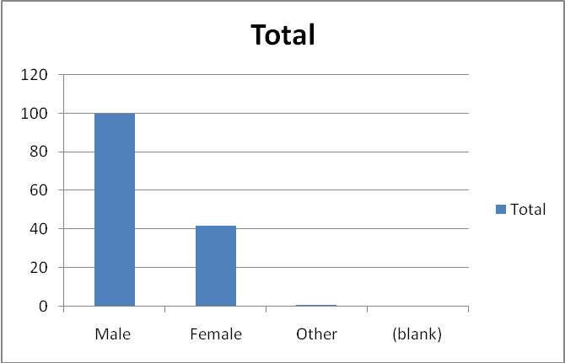
Table 2
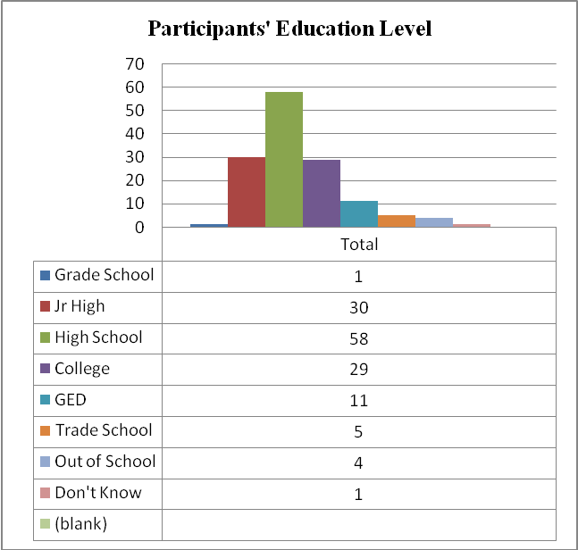

The educational level of the participants was significant in that 58 had a high school education and 29 had a college education. The participants listed the number of people who lived in their households, and the mean for the number of persons living in the participants’ household was 4.
Table 3
Means, for Demographic Variables

Mean SD

Age 20.7 2.2
School grade 7.1 2.4
Total number of people in home 4.0 1.9
Head of household's education level 12.5 2.5

The race of the participants as listed in table 4 were 58 Blacks, 35 Whites, 38 Latinos,
3 Indians, 12 Asians, 11 others living in Springfield and Worcester, Massachusetts.
Table 4
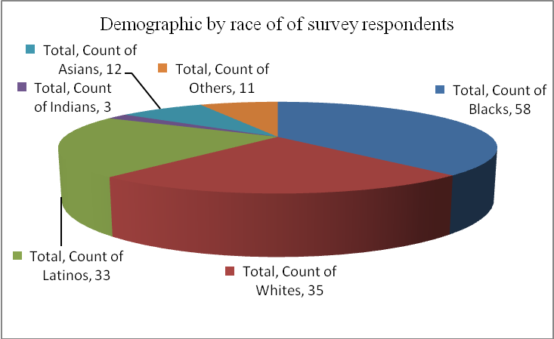
Correlation Findings Media Exposure and Gang Involvement
Only 145 participants out of the original 150 responded to the question “are you or have you ever been in a gang?” Some 28 respondents said yes they are currently in a gang or were once in a gang. Of this group, 25 were males and 3 were females. The results also show that the participants had joined gangs early, some as young as 9 years old. However, the average age for participants who joined gangs was 14 years. In addition, 64 respondents of the 151 surveyed said they had friends currently in a gang, and 42 respondents stated they had family members currently in a gang. The author felt it was important to know why participants had joined gangs.
Results from the research show that 80% of the females and 40% of the males joined because they had friends or family who joined gangs. Having family and peer affiliation with gangs was a strong predictor (risk factor) of gang involvement.

Table 5
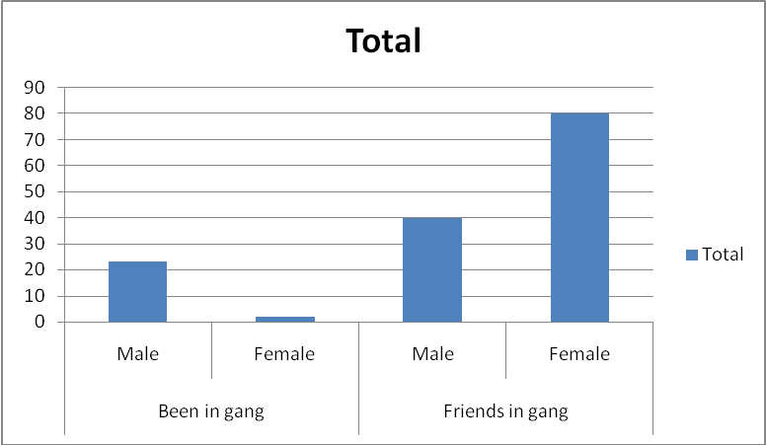

Exposure to Violence in Media
Interestingly the amount of exposure to violent television content, violent video games, violent movies correlated with a preference for violence in television, movies and video games. When the survey participants were asked “what was your favorite movie”, 38 of the 98 respondents listed a movie that had the following rating classification, AC for Adult Content, AL for Adult Language and V for violence. In the survey, all 28 participants who had self-identified as gang members had selected movies and video games with violent classification.

Table 6

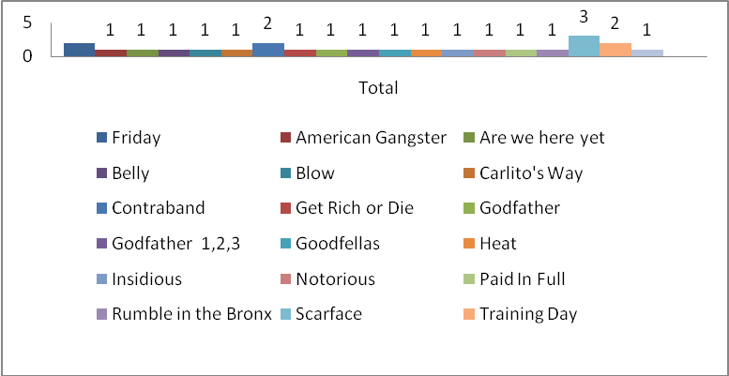
Violent Movies and Video Games
Some 145 survey participants responded to the question “how many hours do you watch movies on weekdays?” The response was that 73 had watched movies one hour daily on weekdays, 45 watched movies two to four hours on weekdays, and 27 said they actually watch movies four or more hours on weekdays. All of the self-identified gang members selected two to four hours of watching movies on weekdays and 4 or more hours on weekends. The self-identified gang members also listed two to four hours of video game usage on weekdays and four or more hours interacting with video games on weekends.
Media exposure increased across the board for all survey participants on weekends. However, those who self-identified as gang members were consistent with an average of four or more hours of exposure to violent material in the form of movies. It was also correlated with a preference for violent video games.

Table 7
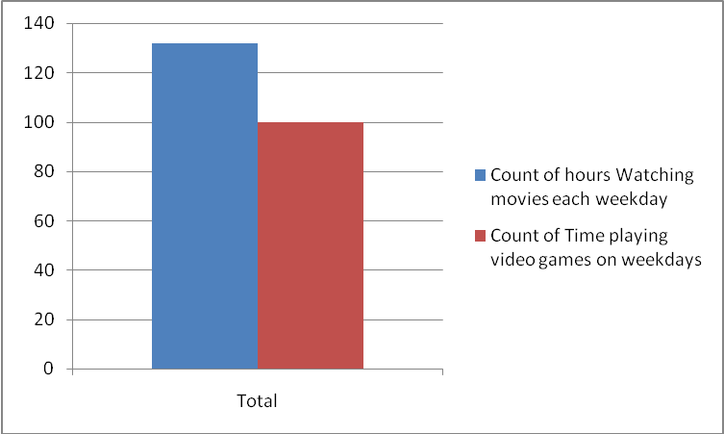
Being Like the Movie Characters
When participants were asked, “do you imagine yourself being like the character in the movies?” Of the 139 participants who responded to the question, 59 said they sometime image themselves like the characters in these violent movies and games, and 25 of the participants stated they often imagine themselves like the characters in these violent movies or games.

Table 8
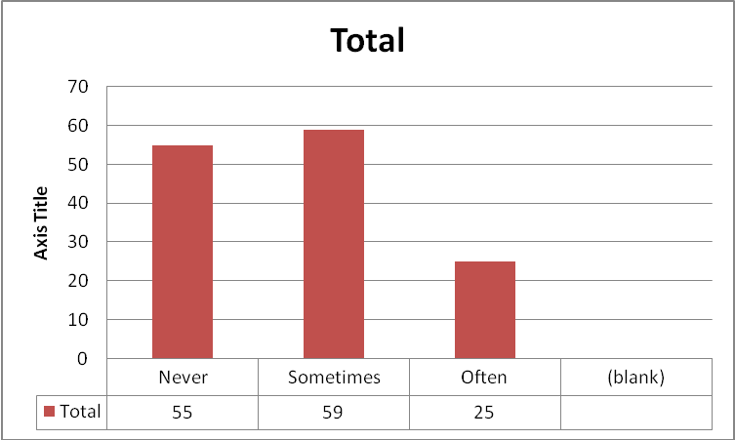
Violence in Music
The results were very similar when looking at the hours the participants listened to music each day. Some 90% of participants averaged 2.1 hours per day, listening to hip-hop (Rap) or R&B music. When asked who was their favorite recording artist, Little Wayne was at the top of the list. As an artist, Little Wayne is known for violent lyrics and his membership in the Bloods street gang.
Table 9
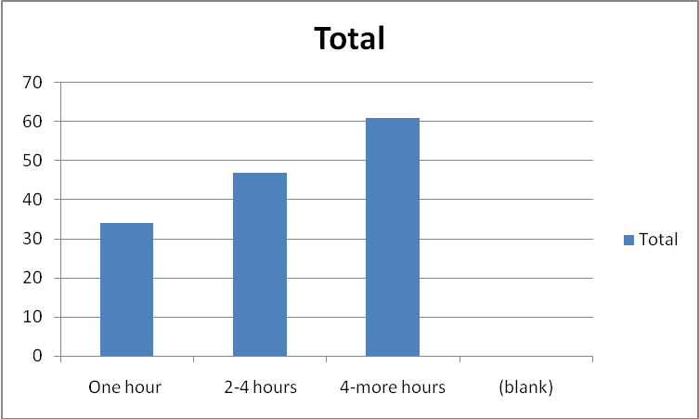
Internet Usage
The participants interacted considerably with internet and social networking sites.
Of the 139 survey participants who responded to this question, 94 said they often go on the
Internet. Some 70% of the self-identified gang members surveyed were also internet and social media users.
Table 10
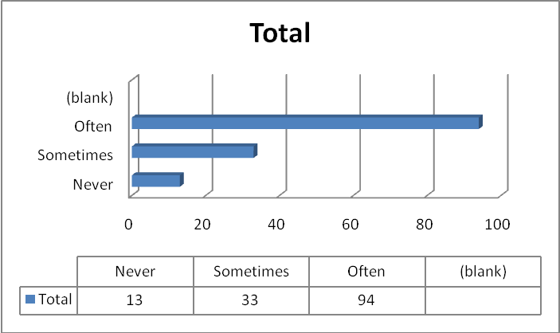
Some 129 respondents answered the survey question “how often are you on the internet or social media sites. Fifty (50) stated they usually interacted for an hour. However, 39 said they were on the sites two to four hours and 40 said they were on the sites four or more hours.
Table 11

Chapter 5

Summary, Discussion, Recommendations
The hypothesis that this author presented in the abstract is supported by the results in this study. One of the greater strengths of the study is that it incorporates authentic measures of media exposure by former and current gang members. The observations and data collection in this study highlighted distinctive differences and predictive behaviors among those non-gang affiliated and gang affiliated survey participants. The results show a preference among gang members for violent media content that far surpassed those of the non-gang affiliated study participants. These preferences accounted for significant proportions of variance in outcomes. This study represents some interesting directions for research on understanding the role played by violent media exposure and its correlation as a risk factor for gang involvement. In several domains, violent media exposure was significantly and positively correlated with the responses from self-identified gang members and their preference for material with violent or aggressive content:
(1) Their choice of music with violent lyrics (Table 9): Violence constitutes a large part of the music preferred by gang members hip hop/rap music, particularly gangsta-rap. This study found that nearly 90% of participants averaged two and one half hours per day, listening to hip-hop (Rap) or R&B music. When asked who was their favorite recording artist, Little Wayne was at the top of the list. As an artist, Little Wayne is known for violent lyrics and his membership in the Bloods street gang.
(2) The choice of movies and television with violent content (Table 6): The study results revealed that the self-identified gang members,watched a greater number of hours of television, movies and interacted with video games for longer periods. Thirty-eight of the 98 survey respondents listed a movie that had the following rating classification, AC for Adult Content, AL for Adult Language and V for violence. In the survey, all twenty-eight participants who had self-identified as gang members had selected movies and video games with violent classification.
Those who self-identified as gang members were more likely to view violence in their favorite selected titles and acquire a preference for the violence in their entertainment medium. The most popular action movies today contain scripts with gender, racial and cultural stereotypes (Latino and Italian organized crime and Black drug dealing and female prostitution). It is no accident that the most successful action films today adhere to these violent media stereotypes. The mainstream media audience including youth has been fed a diet of violent media roles for years and many have come to accept them as reality.
(3) Those who identified as gang members spent longer hours with violent media and had greater access, having reported that the vast majority of them have two or more televisions in the home. The study participants are inadvertently exposed to movie and television violence, due to the sheer number of hours they reported spending with these media. Research by the American Academy of Pediatrics suggests that the amount of time children spend in front of the screen is an important predictor of cognitive, behavioral, and physical outcomes in children. These participants also listed having more control of the choice of what stations to watch. They may also have spent more time engaged in these media forms with less parent supervision of their activities and viewing material.
(4) Choice of movie and video themes with violent content and violent characters
(Table 5): All (100%) of self-identified gang members selected movies and video games with violent content as their favorites. They were also the greater number of those who stated they image themselves being like the characters in their favorite movies (Table 8).
(5) The participants in the study also detailed intensive use of the Internet. Those who self-identified as gang members listed a greater number of hours on the internet with social networks. Unfortunately, video game sites where not listed as a selection in the study and only social networking sites were on the survey.
(6) Considerable creditability and validity, of the study was enhanced through the participation of self-identified gang members and non-gang, normative group ( high school, to adult) The selection allowed this study to measured media usage and preferences of gang members as well as non-gang members.
(7) One of the more surprising results from the study was the demographic data on the participants and their families. According to the survey results, it could be argued that there is a correlation between media violence exposure and gender differences. There was almost twice the number of male self-identified gang members as female. Prior research has shown that boys are more likely than girls to be physically aggressive and the current study shows that boys are also more likely to select and consume violent media material.
The demographic background of the study participants did not correlate with prior research where parents of gang members were thought to be uneducated or on the low socio-economic ladder. The study results demonstrated that many of the self-identified gang members where high school educated (Table 2) and had parents that where college educated (Table 3).
(8) Another surprising result was that prior studies had identified that people were lured to gang life for protection, excitement or the desire to belong to something. However, none of the participants in this research study identified these reasons for joining gangs. The vast majority listed, that having friends or family members in gang life was the primary reason why they joined a gang (Table 5).
To summarize, prior research has established that there is a cumulative effect of risk factors for gang membership, and that risk factors in multiple domains increase the probability of gang involvement. This study expands upon that research by adding violent mass media as another identified risk factor. The results of this study show that gang-involved youth and adults watch a higher proportion of violent movies and television, and play a higher proportion of video games involving violence than the non-gang affiliated participants. Prior research has shown that individuals with high exposure to media violence on television, and movies are likely to become desensitized to violence in real life. The participants who self identified as gang members had greater access to violent media material as they listed themselves as the primary person to choose what movies they watched. They also had greater access to the medium with a greater number of televisions available to them in their homes.
Finally, this study has brought into question whether the long-term exposure to violent media content is intergenerational. Many of the study participants listed that their family members where also in gangs. One area for further study could be whether their parents and family members had consumed violent media material in the same way.The study was limited in it’s ability to capture data on violent media exposure of parents and family members and the correlation to media use patterns of the current studies participants. Future studies may consider the question can intergenerational media use patterns contribute in some way to current patterns of useage by study participants ? Survey data shows gang involvement by a majority of the familiy members, however the survey did not capture media use. Future studies could be developed to capture this data.
Future findings could support the importance of addressing the issue of violent mass media exposure through education of parents and their children. If the next generation of youth faces the same environmental risk factors as their parents or older siblings we can expect another generation at risk for gang involvement

Appendix I
Consent to Participate Form
SURVEY CONSENT FORM
This survey is part of a research project to learn more about how youth who are exposed to violent media material (Television, movies, video games, and internet) are put at risk for exhibiting violent behavior. By completing the survey, we hope to use the information to design programs and strategies to reduce the negative impact of violent mass media material on youth.
We will not request personal information like names, address or ask other questions that identify the person completing the survey. Only the researchers will see the results of the survey and no name will be on the survey. The survey is voluntary and there is no compensation or payment of any kind for your participation. However, you will be contributing to an effort to keep our youth safe and enhance the health and wellbeing of our community.

- Yes, I would like to participate in the survey. I have read the information above and understand my participation is completely voluntary.___________.
Initials

- Yes, I am a parent or guardian of this survey participant and by signing my initials give my permission for him/her to participate. _______________.
Initials

Appendix II
Mass Media Violence A Risk Factor for Gang Violence
An Independent Research Project Survey

Personal Characteristics – Information About You
- Age
- Race Black White Latino Indian Asian Other
- Gender Male Female
- Education Grade School Junior High High School College
GED Trade School Out of School
- Zip Code
Information About Your Family
- How many people live in the house or place where you live?
- Parents ____ Children _____ Other Adult Family_____ Non Relatives ______
- Fathers Education Grade School Junior High High School
College GED Trade School Don’t Know
- Mothers Education Grade School Junior High High School
College GED Trade School Don’t Know
Gang Involvement
- Are you in a gang? Yes No
- Are any of your friends in a gang? Yes No
- Have you ever been in a gang? Yes No
- Are any of your family members in gangs? Yes No
- How old were you when you first joined a gang? _______
- What is the reason you joined or would like to join a gang?
Friends are in a gang Want to belong to something Protection
Excitement -Popularity Intimidated –Forced Family member in gang
Music
- What kind of music do you like and frequently listen to?
Pop Rock Hip Hop R&B Techno Country
Disco Blues Jazz Other
List three favorite Artist __________________________________________________
17. What do you enjoy most ? Music-Beats Lyrics-Words
18.Do you understand and relate to what the artist says in their recordings?
Often Sometimes Never
19. How often do you listen to music each day? 1hour 2 - 4 more
Movies
20. Do you go to the movie theater? Never Sometimes Often
21. How often do you watch movies on television? Never Sometimes Often
22.Do you watch movies on DVD? Never Sometimes Often
23.List three of your favorite movies.
24.Do you ever image yourself being like the characters in your favorite movie?
Never Sometimes Often
25.How often do you watch movies on weekdays? 1 hour 2-4 More
Video Games
26. Do you have a video game console? Yes No
What type? Xbox Play Station Wii DSL
27.How often do you play video games on weekdays ? 1 hour 2-4 More
28.How often do you play video games on the weekend ? 1 hour 2-4 More
29.List three of your favorite video games?
30.Do you usually play video games alone ? Yes No
31.Do you ever image yourself being like the characters in the video game?
Yes No Sometimes

Internet
32. Do you go on the Internet? Never Sometimes Often
33. Do you have a personal profile on a social network site? Yes No
Face book My Space Twitter You Tube
34. How often are you on these sites ? 1hour 2-4 More
Television
35. On weekdays how many hours do you watch television? 1 hour 2-4 More
36. How do you usually watch television? Alone With Friends Family
37. Do you choose what stations you watch? Never Sometimes Always
38. When watching television with others do you talk about what you see?
Yes No
39. Do you have a television set in your room ? Yes No
40.What are three of your favorite television programs?
41. How many television sets do you have in your home? 1-2 3-4 more
42.How many hours of television do you watch on weekdays? 1-3 4 or more
43. How many hours of television do you watch on weekends? 1-3 4 or more

References
Anderson,C., Berkowitz, L., Donnerstein, E., Huesmann, R., Johnson, J., Linz, D.,
Malamuth, N.J., & Wartella, E. (2003). The influence of media on youth. Psychological
Science in the Public Interest, 4,(3),81-110. doi: 10.1111/j.1529- 1006.2003.pspi_1433.x Anderson, C.A., Bushman, J. (2010). Much ado about something:Violent video game effects
and a school of red herring. American Psychological Association, Psychological Bulletin, 136, 182–187. doi: 10.1037/a0018718
Bok,S. (1998). Mayhem: Violence as public entertainment. New York, NY: Perseus Books
Publisher, LLC
Boxer, P., Huesmann, E., Bushman, B., O’Brien, M., & Moceri, D. (2009). The role of violent
media preference in cumulative developmental risk for violence and general aggression. Journal of Youth Adolescence, 38,417–428. doi: 10.1007/s10964-008-9335-2 i
Buchanan, A., Gentile, D., Nelson, D., Walsh, D., & Hensel, J.(2003). What goes in must come
out: Children’s media violence consumption at home and aggressive behaviors at school. Retrieve from http://www.psychology.iastate.edu/~dgentile/VMPR%20SRCD%20Paper.pdf
Carlie, M. (2002). Into the abyss: A personal journey into the world of street gangs.
Springfield,MO: Self-Publication.
Carll, E. (2007). Violent video games: Rehearsing aggression, The Chronicle of Higher
Education, 53.45. Retrieve from.http://chronicle.com/article/Violent-Video-Games-/22641/

Catalano, R., & Hawkins,D. (2001).Communities That Care. Channing Bete Company,
Deerfield, MA
Centers for Disease Control and Prevention (2011). Health Disparities and Inequalities Report,
MMWR 2011,60: 67-70. U.S. Department of Health and Human Services, Atlanta, GA.
Retrieved from http://www.cdc.gov/mmwr/pdf/other/su6001.pdf
Christakis, D., Zimmerman, F. (2007).Violent television viewing during preschool is
associated with antisocial behavior during school age. Pediatrics, (12), 120-993
doi: 10.1542/peds.2006-3244
Clinton, W., & Gore, A. (1999). The White House Strategy Session on Children, Violence
and Responsibility. Washington Press Corp,Washington DC. http://clinton4.nara.gov/WH/Work/051099.html
Daley, R. (2008). An abstract of exposure of U.S. adolescents to extreamly violent movies,
American Psychiatric News, 43,19-21 http://pnhw.psychiatryonline.org/content/43/19/21.full
Diego, J. (2002). A rainbow of gangs: Street culture in the mega –city. Austin ,Texas:
University of Texas Press
Egley,j., Howell, J.C., & Moore,J.P.(2011). Highlights of the 2009 national youth gang
survey,U.S. Department of Justice: National Gang Center,.http://www.nationalgangcenter.gov/Survey-Analysiss
Fish, H. (1984). U. S. Congress House of Representatives United States Comprehensive
Crime Control Act of 1984, H.R. 5963 , NCJRSAbstract Database, National Criminal Justice Reference Service. National Institutes of Justice, Rockville, Maryland.) Retrieved from http://www.ncjrs.gov/App/Publications/abstract.aspx?ID=123365
Hatch, O. (1999). Marketing Violence To Children: S. HRG. 106–1144:Hearing before the
Senate Committee on Commerce, Science, 106 th Cong.
Hochman,S. (1989, October,5). Compton rappers versus the letter of the law: FBI claims song by
N.W.A. advocates violence on police.The Los Angeles Times, Retrieved from http://articles.latimes.com/print/1989-10-05/entretainment/ca-1046-1-law-enforcement
Howell, J. (2010). The impact of gangs on communities. Juvenile Justice Bulletin,
Youth Gang Series. 8,1-2. Washington, DC: U.S. Department of Justice, Office of Juvenile Justice and Delinquency Prevention. Retrieve from. http://tussingblockwatch.com/attachments/Impact-of-Gangs-on-Communities.pdf
Huesmann, R., & Miller, L. (2011). Long-term effects of repeated exposure to media violence in
childhood. Aggressive Behavior: Retrieved from
http://www.rcgd.isr.umich.edu/aggr/articles/Huesmann/1994.Huesmann&Miller.LongTermEffectsofRepeatedExposuretoMediaViolenceinChldhd.inAggBehav.pdf
Huesmann,L., & Tversky,N. (2007).The impact of electronic media violence: Science theory and
research. Journal of Adolescent Health,41,1-12. doi:10.1016/j.jadohealth.2007.09.005
Jipping, T. (1999). Diagnosing the cultural: Music, a medium more powerful than television
or videos, has a profound effect on the formation of values among children.WorldandI.com, Retrieve from. http://worldandi.misto.cz/_MAIL_/ article/cijul99.html.
Jipquep, M., & Phillipak, (2003). The context of violence for children of color: Violence in
community and in the media. Howard University Journal of Negro Education. 72(4),371-378. Retrieve from . http://www.jstor.org/stable3211189
Kidder, J. A. (2007). Achieving peace in the streets: How legislative efforts fail in combating
gang violence in comparison to successful local community-based initiatives. New England Journal on Criminal and Civil Confinement, 35,254-255. https://litigation-essentials.lexisnexis.com/
Knox,G.(2011). Gang members on facebook: Should we look the other way? A Special Report
of the National Gang Crime Research Center, Retrieve November, 15 2011, from. http://www.ngcrc.com/gangface.html
Krahe, B., Möller, I., Huesmann, R. Kirwil, L. Felber, J., & Berger, A. (2010) Desensitization to
media violence: Links with habitual media violence: Exposure, aggressive cognitions, and aggressive behavior. American Psychological Association , Journal of Personality and Social Psychology, 630-645.doi: 10.1037/a0021711
Kronenberger, W., Mathews, V., Dunn,D. Wang, Y., Wood, E. , Larsen, J., & Rembusch, M.
(2005). Media violence exposure and executive functioning in aggressive and control adolescents. Journal of Clinical Psychology. 61(6), 725–737 . DOI: 10.1002/jclp.20022
Kubrin, C., & Weitzer, R. ( 2003). New directions in social disorganization theory, Journal of
Research in Crime and Delinquency, 40, 4, 374-402. DOI: 10.1177/0022427803256238
Lambert,S. F., Ialongo, N.S., Boyd, R.C., & Cooley, M.R., (2005). Risk factors for community
violence exposure in adolescence, American Journal of Community Psychology, 36, 8
doi: 10.1007/s10464-005-6231-8
Lynch, A. (2005). US: The Media Lobby. Retrieved from
http://www.corpwatch.org/article.php?id=11947
Miller, R. (2004). Random acts of violence. New York, NY. Rosen Publishing Group
Nagel, J. (2009). Violence in Movies, Music and The Media. New York, NY.The
Rosen Publishing Group,Inc
Olson, C. (2004) Media violence research and youth violence data: Why do they conflict?
Academic Psychiatry, 28, 144-149 Retrieve from
http://ap.psychiatryonline.org/article.aspx?articleid=48012
Przemieniecki, C. (2005). Gang behavior and movies: Do hollywood gang films influence
violent gang behavior? Journal of Gang Research, 12, 2,41-71 Retrieve from
http://www.ngcrc.com/ngcrc/page2.htm
Reed, W.L., Decker,S.H., & Weisel, D. L. (2002). Responding to gangs, evaluation and
research. U.S. Department of Justice,National Criminal Justice Reference
Service, Rockville,MD
Rockefeller, J. (2009). Rethinking The Children’s Television Act For Digital Media Age. HRG.
111-485. Hearing before the Committee on Commerence and Transportation. United
States Senate, 111th Cong. 7.
Sharp, E. (2003). The impact of age upon the risk factors for gang membership.
Journal for Juvenile Justice and Detention Services, 18, 1,,51-52
Sheidow, A., Smith, D., Tolan, P.& Henry, D. (2001). Family and community
characteristics:Risk factors for violence exposure in inner –city youth.
Journal of Community Psychology 29, 3, 345–360 Retrieved from http://www.centerforyouth.org/%2Ffiles%2FRiskFactorsforViolenceInnercityyouth.pdf
Smith, D. & Tolan, P. (1998). The role of exposure to community violence and developmental
problems among inner-city youth. Development and Psychopathology. 10,101-116
Thomas, P.R. (2010). Violent video games: Restricting the sale of games with graphic content
to minors, Violent video games impact;Supreme Court Debates., Congressional Digest Corp. 13, Retrieved from http://congressionaldigest.com/issue/violent-video-games

Turner -Essel, L. (2011) Youth violence in the U.S.: An existential crisis. VoxUnion.,12, 43
Retrieved from,http://www.voxunion.com/?p=4050
U.S. Department of Justice ,Office of Juvenile Justice and Delinquency Prevention Juvenile Justice Bulletin. 12,3-6. .https://www.ncjrs.gov/pdffiles1/ojjdp/231116.pdf
Vivian, J. (1999). Media effects:The Media of Mass Communications. (pp.383-
409). Viacom Co, Needham Heights, Massachusetts.
Yoshiro, O., & Pumariega, A.J. (2008).Violence in youth: International Review of
Psychiatry. 20, 305–316. doi: 10.1080/09540260801990241

